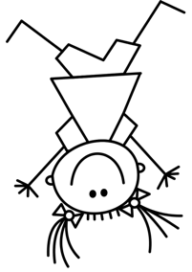
Class Survey: Favourite Book
What is your favourite book?

My favourite book is…

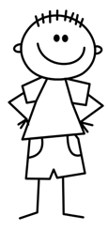
Ask your classmates.

Name | (Picture of the book) | (Picture of the book) | (Picture of the book) | (Picture of the book) | (Picture of the book) | (Picture of the book) | (Picture of the book)

